Gas Leakage Detection with Buzzer System using Atmega
Gas leaks within the home are usually the results of poorly fitted, badly maintained or faulty appliances like boilers and cookers. There are several deaths per year linked to gas leaks in addition to hundreds of hospitalizations, gas safety is something every household should take seriously. To reduce this accident, we can detect the gas leakage using the MQ5 gas sensor. Firstly, when we turn on the power to the circuit, the project automatically gets connected to the WIFI and the IOT site, once the connection to Wi-Fi and the IOT site is established, the system waits for the user to manually enter the minimum and maximum values on the IOT site, once the user enters the data is received by the system. The RGB LED on the project turns to Green once data has been successfully received, then the project continuously monitors the amount of gas in the air, when the gas exceeds the set limit the motor rotates indicating the closure of the valve & buzzer starts buzzing and the LED turns red to indicate excessive Gas.

Block Diagram:
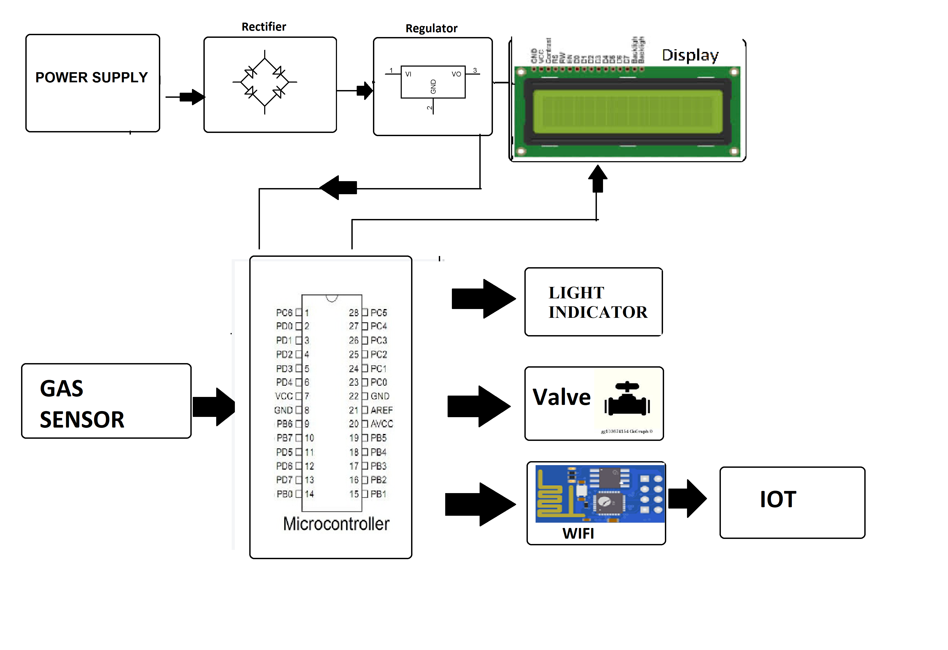

Hardware Specifications

- Atmega Microcontroller

- LCD

- Wi-Fi Module

- Gas Sensor

- Crystal Oscillator

- Resistors

- Capacitors

- Transistors

- Cables and Connectors

- Diodes

- PCB and Breadboards

- LED

- Transformer/Adapter

- Push Buttons

- Switch

- IC

- IC Sockets

Software Specifications
- Arduino Compiler
- Programming Language: C

